Bridgeport High School Alumni Association

2015 Newsletter



dglxasset[1]

2015 Newsletter

Volume 1 Issue 1

**Events**

May 24th – HS Graduation

Jun 26th – Niekro Classic

Golf Scramble

Jun 26th – Alumni Social

Jun 27th - Alumni Banquet

Sept 11th – BHS Hall/Wall of Fame Football Game

Sept 12th – BHS Hall/Wall of Fame Banquet

BHS ALUMNI ASSOCIATION

Board of Directors

President

Michael Terek ‘90

Vice President

Melissa Nagy Patroski ‘91

**Secretary**

Dory Bradley Lucas ‘72

**Treasurer**

Jeff Grandstaff ‘75

**Board of Trustees**

Sharon Piccin Acosta ‘65

Tom Blust ‘89

Don Cash ‘75

Carol Stazenski Campbell ‘63

Sean Caruth ‘88

Ted Ehni ‘51

Heidi French ‘89

Larry Lawson ‘02

Gordie Longshaw ‘65

Pat McConnaughy ‘87

Bob Weaver ‘62

David Weaver ‘86

The Bridgeport High School Alumni Association proudly announce plans for this year’s Annual Alumni Weekend, to be held Friday and Saturday, June 26th and 27th.

The events kick off on Friday with the Annual Niekro Classic Golf Scramble at the Belmont Hills Country Club in St. Clairsville. The scramble begins bright and early with an 8:30 a.m. shotgun start. Then that evening from 6 pm to 9 pm, there will be the 2nd Annual Alumni social time at the Rhodes Skyliner (old Bridgeport Eagles). The main downstairs hall will be available to all alumni with pizza and BYOB. Donations to help offset the cost of the room rental will be appreciated. There are also 3 or 4 private rooms available for class reunions that night. Any class interested, should call Rhodes Florist at 740-635-0512.

The weekend continues at the Annual Alumni Banquet on Saturday, at the Rhodes Skyliner in Bridgeport. Class photos begin at 5:30 p.m. Dinner buffet will be served at 6 p.m. Our program this year includes speakers from the 25 and 50 year classes. Inductees into the BHS Alumni Hall of Fame will be Carol Grandstaff ’55, Allan Ketzell ’63, Steve Kish Jr. ’65 and Gordie Longshaw ‘65.

Please note that in order to insure proper numbers for seating and dinner, reservations are required. The cost for the banquet is $30.00 per person. There is NO CHARGE for the Class of 2015 and the Golden Anniversary Class of 1965; however, you must send in the reservation form to insure seating needs are met. Reservations deadline is June 15th. It is also time to support the Bridgeport High School Alumni Association with your membership renewal. Member dues are $5.00 per year. We ask that you pay your dues whether you are planning to attend the banquet or not. These funds allow continued operations of your BHS Alumni Association.

DJ Bill Talik ’81 will be on hand both nights playing tunes from the past. Bring your requests!

**2015 Alumni Weekend Planned**

The golden anniversary class of 1965 will begin our celebration on Friday night, June 26th, at the Wheeling Island Hotel Casino and Racetrack. Festivities will begin at 5:30 p.m. with drinks and a social hour, followed by pictures and dinner. Saturday will be the annual alumni banquet at the Skyliner in Bridgeport, and a class picture at 5:30 pm. We are looking forward to our new banquet venue and celebrating two of our classmates’ induction into the Alumni Association Hall of Fame. Sunday, June 28th will be the traditional brunch at the Belmont Hills Country Club. We are looking forward to seeing everyone in June 2015, and having the best ever 50th celebration!

**Alumni Banquet Moved to Skyliner in Bridgeport**

Due to attendance at recent banquets going down and costs going up, along with the success of our inaugural Friday night event last year, the annual Bridgeport High School Alumni Banquet is being moved to the upstairs ballroom at the Skyliner. Located at the former Eagles building, the Skyliner has been renovated into one of the finest facilities in the Ohio Valley with a great staff and great food, and located right here in our hometown. Please visit the Skyliner’s Facebook page for pictures and information on the facility. The Marion Street Bridge is being replaced and there will be some traffic pattern changes in Bridgeport. Check our Facebook page for updates.

## Class Reunion News

of 4

Newsletter

**Alumni Email Address and Facebook Page**

The Alumni Association now has an email address. Alumni can send any questions or comments to us at [bulldogalumni@outlook.com](mailto:bulldogalumni@outlook.com). Also Alumni can visit our Facebook page – Bridgeport High School Alumni – Bridgeport, Ohio for the latest Alumni news and Alumni Memorabilia available for sale. If you haven’t already joined our Facebook page visit us today. We currently have over 1,000 Alumni on our page.

**2015 Alumni HOF**

**Inductees**

**Carol Grandstaff ‘55**

**Allan Ketzell ‘63**

**Steve Kish Jr. ‘65**

**Gordie Longshaw ‘65**

**John and Norma Miller–Daffin Educator’s Scholarship Established**

The mission of the John and Norma Miller-Daffin Educator’s Scholarship is to provide financial assistance to selected college Junior and Senior students who graduated from Bridgeport High School or a Belmont County, Ohio high school and are majoring in Early Childhood or Elementary Education. The enduring goal of this scholarship is for recipients to become an Early Childhood or Elementary Education teacher. The award will be $5,000 per scholarship, number of awards may vary from year to year. Graduates of Bridgeport High School, Bridgeport, Ohio, will be given first consideration. If there are no Bridgeport High School Candidates then graduates from any high school in Belmont County, Ohio will be considered.

Eligibility: A rising academic Junior or Senior majoring in Early Childhood or Elementary Education, a GPA of 3.0 or higher, and enrolled at any accredited four-year institution in the United States. Candidates will be selected in the following order:

Early Childhood Education (Pre-K to 3rd grade) – 1st Preference

Elementary Education – 2nd Preference

Eligible candidates must submit an application to the Community Foundation for the Ohio Valley, which includes: An official copy of the candidate’s academic transcript (mailed or emailed) from the college to the Community Foundation, a 500 word essay discussing: career aspirations and life goals, reasons for choosing Early Childhood or Elementary Education as a major, academic achievements, and other activities. Candidate must demonstrate financial need as determined by the candidate’s Student Aid Report.

If the Scholarship is awarded to an academic Junior, then this candidate will be given first consideration for a renewal of the scholarship for the Senior year. The candidate must provide an official transcript to the Community Foundation from their college of enrollment showing a continuing GPA of 3.0 or higher.

Community Foundation for the Ohio Valley, 1310 Market Street, Suite 1, Wheeling, WV, 26003, [www.cfov.org](http://www.cfov.org),

(304)-242-3144.

dglxasset[1]

**Alumni Trivia – How the Bulldogs came to be**

Being dissatisfied with the former nicknames Bridgets, Reitermen, Castilomen, and Bakermen, the students of Bridgeport High School came to the conclusion it was time to give themselves a fitting sobriquet.

All other schools in the valley had appropriate names, but it seemed to be that Bridgeport High School had too many.

To eliminate these difficulties, a contest was organized and as a result, we now have the appropriate name of “Bulldogs”. The contest was held in 1932. Any member of the school was eligible to submit their suggestion. Mr. Baker, as chairman, was assisted by a committee composed of a representative of each class. Dr. J.O. Howells, Mr. H Ely, and Mr. H Waldorf counted the votes of those suggestions taken from the box which was placed in Mr. Waldorf’s office. The name receiving the most votes was chosen.

The winner, Joseph Pitner, a member of the Sophomore class at the time, received a pass for football, basketball, and baseball games.

Name _________________________

Maiden Name ___________________

Address ________________________

City ___________________________

State __________ Zip ____________

Phone____________ Class Year _____

Email ___________________________

PLEASE RETURN THIS FORM TO:

BRIDGEPORT HIGH SCHOOL ALUMNI ASSOCIATION,

PO BOX 132,

BRIDGEPORT, OHIO 43912

Annual Dues

#_____ Dues @$5.00 $ _____

Donations

_____ BHS Scholarship Fund $ _____

_____ BHS Alumni Fund $ _____

Banquet Reservations

#______ Banquet Reservations @ $30.00 Each $ _____

#______ Banquet Reservations – Class of 1965 $ _____

#______ Banquet Reservations – Class of 2015 $ _____

*Even if your dinner is free….you must make a reservation.*

*Reservation Deadline – June 15th*

*Dinner tickets will not be mailed—your reservation will be at the door.*

**TOTAL AMOUNT ENCLOSED $ _______**

dglxasset[1]

The annual Bridgeport Hall/Wall of Fame weekend was held September 5th, and 6th, 2014. Inductees were introduced at halftime of the home opening Football game on Friday September 5th against Toronto. The following evening the inductees were honored at the Hall/Wall of Fame Induction Dinner held at The High School Cafetourium. Honorees are Coach Floyd Baker and the 1936 State Semi-Finalist Basketball Team, the 1958 Football Team, which was the school’s first undefeated Football Team, Brian Stewart ’80, for his exploits on the basketball court and baseball diamond, and Cindy Gary Cash ’81, who was the first female basketball player at Bridgeport High School to score 1,000 points. To nominate a graduate for future induction to the Bridgeport High School Hall/Wall of Fame, please download the nomination form from [www.bevs.k12.oh.us](http://www.bevs.k12.oh.us)

This was also the annual appearance of the Bridgeport High School Alumni Band. 17 members, representing classes from 1964 thru class of 2014 graduate Brianna Reynolds returned. The band marched onto the field and took part in all pre-game festivities including playing of the National Anthem and Alma Mater. The band plans to return in 2015 and participate in all the evening’s activities including the halftime induction ceremony. The band wants to continue to grow and invites all former band alumni back for the 2015 game for an evening of fun and to share memories of their days as a Bulldog band member. Please visit the band’s Facebook page for more details. Hall Of Fame weekend 2015 will be September 11th and 12th, 2015.

PLEASE RETURN THE FORM ABOVE WITH YOUR DUES, DONATIONS, AND DINNER RESERVATIONS

********************** Please return the form above with your dues, donations and dinner reservations. ***********************

## Hall Of Fame / Wall of Fame Weekend and Alumni Band News

## Alumni News

The 4th annual National Wrestling Hall Of Fame Ohio Chapter induction ceremony had a Bridgeport flavor to it as four former Bulldogs were among the 11 distinguished honorees. The ceremony was held on Sunday October 19, 2014 at the Embassy Suites in Dublin, Ohio.

Arthur R. Hehr ’59, Bobby Douglas ’61, Andrew Chick Lamotte III ’65, and Steve Kish Jr. ’65 comprised the Ohio Valley Contingent. Douglas received the Legacy Award, Lamotte received the Medal of Courage Award, and Hehr and Kish each received the Lifetime Service to Wrestling Award. The Legacy and Medal of Courage Award are the top two awards, while the Lifetime Service Award is for years of dedication to wrestling as a coach, official, or contributor to the sport. Congratulations to these former Bulldog Wrestling greats!

Alumni dues, Scholarship or Alumni fund donations can be made thru Pay Pal. Visit Pay Pal and search for the Bridgeport page - [Bridgeportalumni@gmail.com](mailto:Bridgeportalumni@gmail.com). You will be able to choose from dues, or donations. Thank You.

**Page 3 of 4**

Lett1er

## BHS ALUMNI ASSOCIATION 2015

Annual Banquet and Membership

## Bridgeport Alumni Association

## P.O. Box 132

## Bridgeport, Ohio 43912

## Alumni Pictures

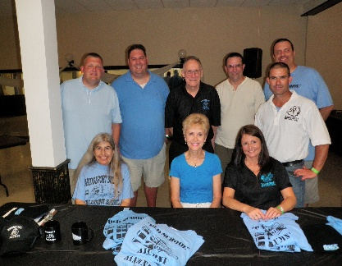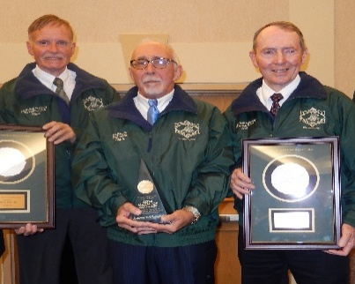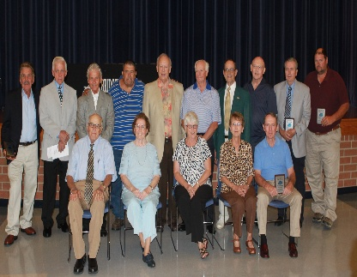

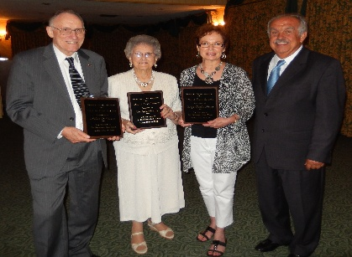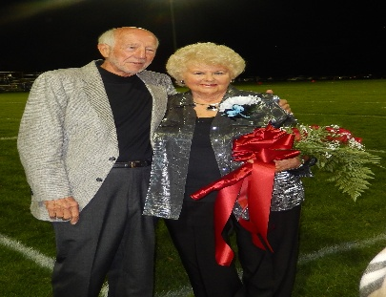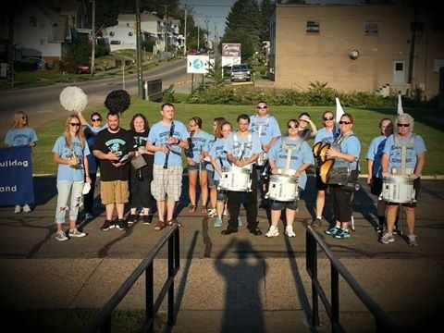

Top Left to right: Alumni Committee at Friday night event; Ohio Wrestling HOF inductees Steve Kish Jr ‘65, Andrew “Chick” Lamotte III ‘65, Art Hehr ’59; 1958 Undefeated Football team;2014 Alumni HOF – Robert Weaver ’62, Dr. John Charlton ‘39, represented by his wife, Marge Charlton, Judge Charles Knapp ‘41, represented by his daughter, Mary Bea Denoble, with committee member Gordie Longshaw ’65; 1954 Homecoming Queen Phyllis Niekro Dillmore ’55, and husband Ed Dillmore ’55, at 2014 Homecoming game; 2014 Alumni Band prior to marching to the field.